**UPDATE ITEM PRICING**

**TO START   
1.) Menu  
2.) Maintenance  
3.) Update item pricing any branches**

Update Item pricing any branches

Maintenance

3 1*1*

2 1*1*

Menu

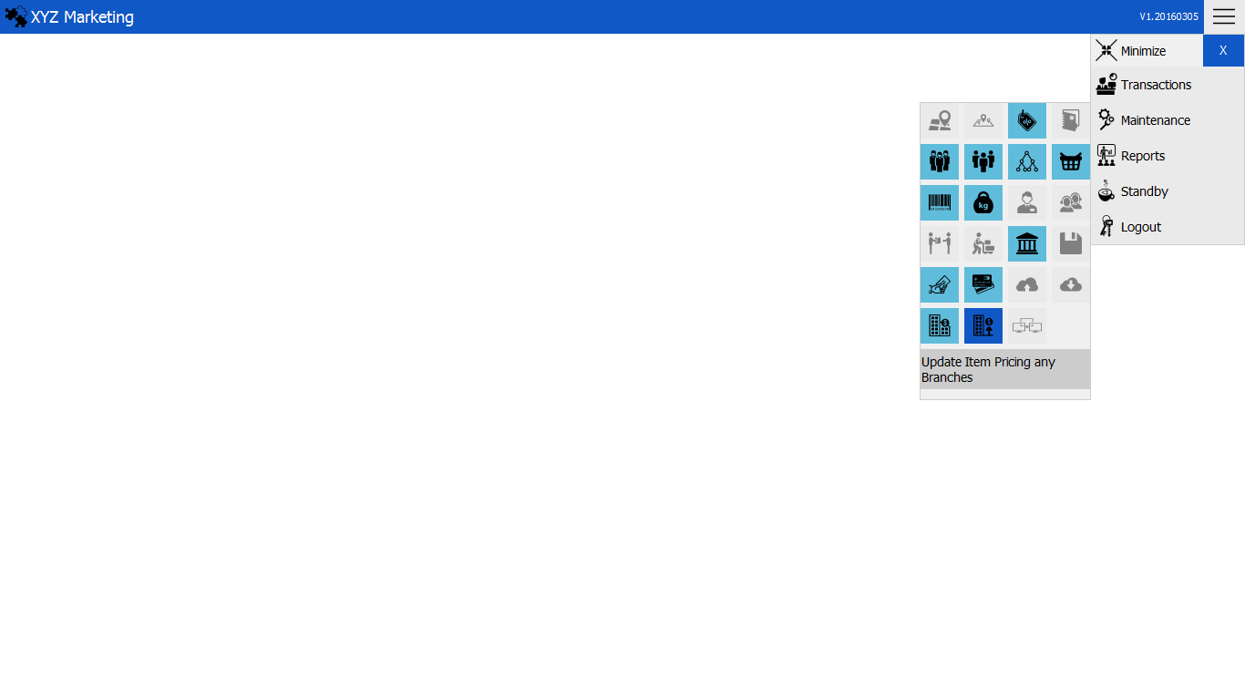

1 1*1*

**UPDATE ITEM PRICE  
1.) Select branch**

**2.) Search item  
3.) Select item to update**

**4.) Finalize**

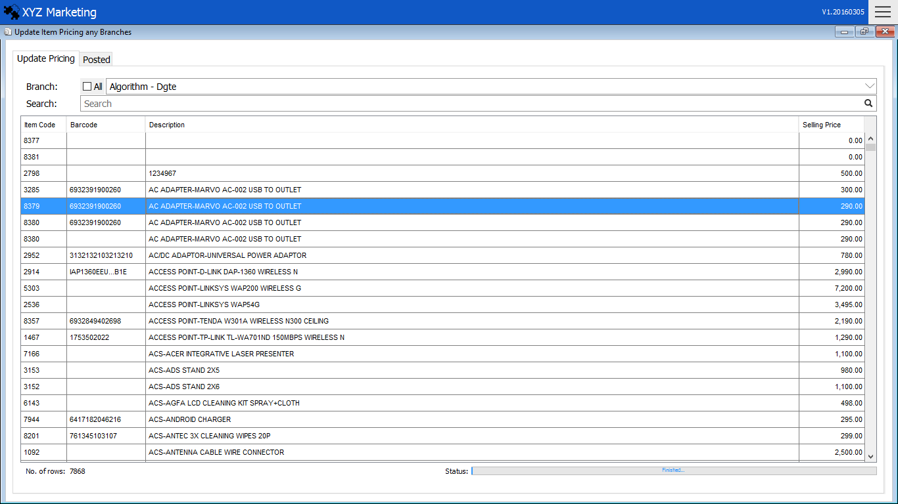

Finalize

Select branch

4 1*1*

Select in the list

3 1*1*

Search item

2 1*1*

1 1*1*

**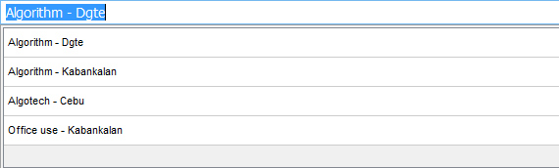  
1.) Select branch**

Select a branch where the item is stock and wanted to update the price.

**2.) Search item**

Search for the item wanted to update the price.

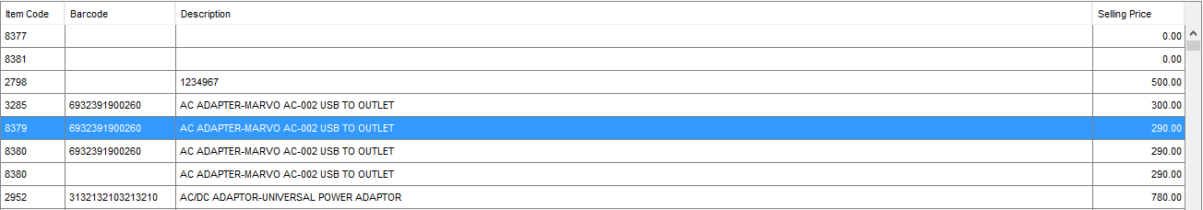 **3.) Select the item in the list**

Select the item from the list and press enter to continue.

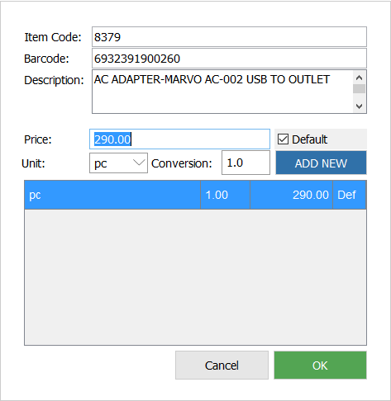

Add

Input the rate of conversion

4 1*1*

3 1*1*

Select Unit of Conversion

2 1*1*

Input new price

1 1*1*

 **3.1) Input new price**

Input the new price of the item.

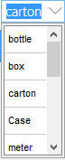 **3.2) Select the unit of conversion**

Select the unit of conversion displayed upon clicking the input box.

** 3.3) Input rate of the conversion**

Input the rate of conversion selected in the unit.

 **3.4) Add**

Click the Add new button to finish adding and click the ok button to continue.

**4.) Finalize**

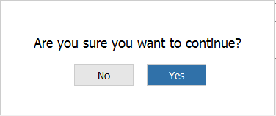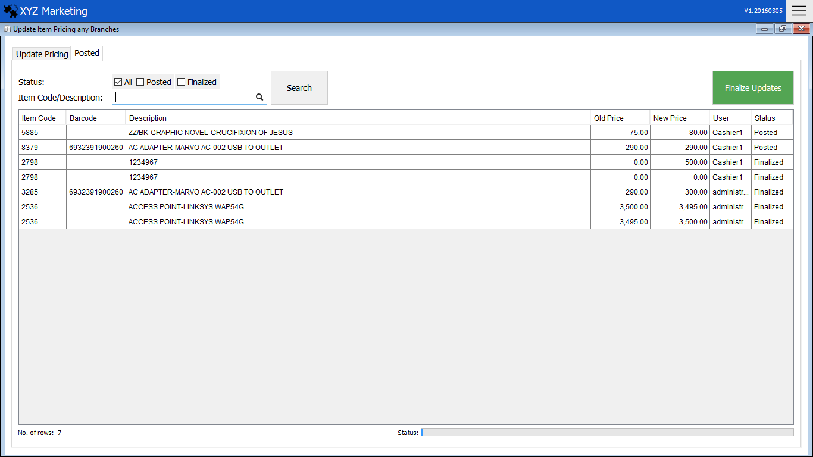

This message will appear after clicking the item in the list and click yes to finish the update.

Status

Click the updated item in the list to finalize.

Finalize

List of Changed price item

Search filter

Posted Tab